PROMIS 4.21.1 Training

CIHI Changes in PROMIS

Summary of Changes in Transplant Procedure

Navigation:
Classic > Transplant > Transplant Procedure

- There are two new drop-down fields in the Transplant Procedure screen in Classic for Heart and Lung transplant patients only.
- Primary Graft Dysfunction
- Primary Graft Dysfunction Grade

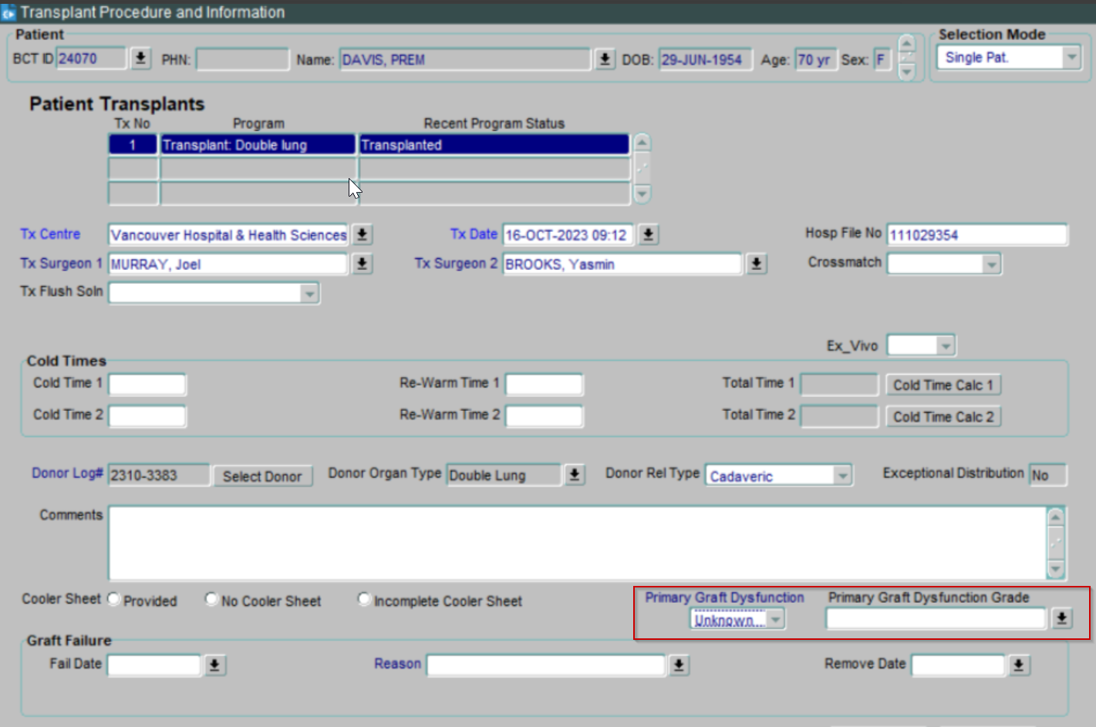

- The Graft Fail Reason drop-down has new items in the list and some existing items have been updated.
- Antibody-mediated rejection
- Cardiac allograft vasculopathy
- Coronary artery disease
- Post-transplant lymphoproliferative disorder
- Primary graft dysfunction
- Rejection after stopping immunosuppression
- Rejection secondary to noncompliance
- Surgical complication: Bowel perforation
- Surgical complication: Other
- Surgical complication: Vascular
- Vascular event in graft
- Venous thrombosis

- The Donor Organ Type drop-down has an updated list of options for Lung transplant patients:

- Left Lung Lower Lobe
- Left Lung Upper Lobe
- Right Lung Lower Lobe
- Right Lung Middle Lobe
- Right Lung Upper Lobe

- The Lobe drop-down has an updated list of options for Liver transplant patients.

- Lateral segment
- Mono segment

Summary of Changes in Activation

Navigation:
Classic > Transplant > Activation

- The Activation screen has a new field Insulin Dependent for Pancreas, Islet and Kidney-Pancreas recipients.
- The ECD field is now available for all transplant programs.
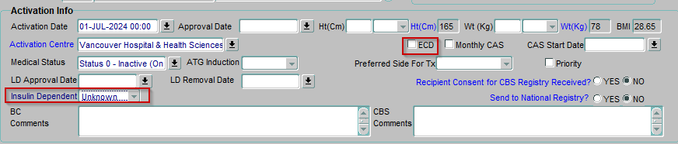
- For Liver transplants, a new field called Meld Exception is available on the Activation screen.
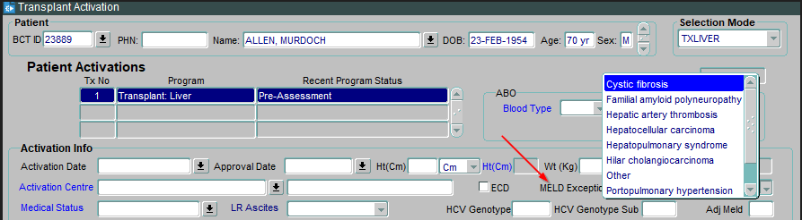

Summary of Changes in Liver Referral Date Summary

Navigation:
Classic > Transplant > Liver Referral Dates Summary
- A field called Living Donor Discussion Occurred is available on the Liver Referral Dates screen.
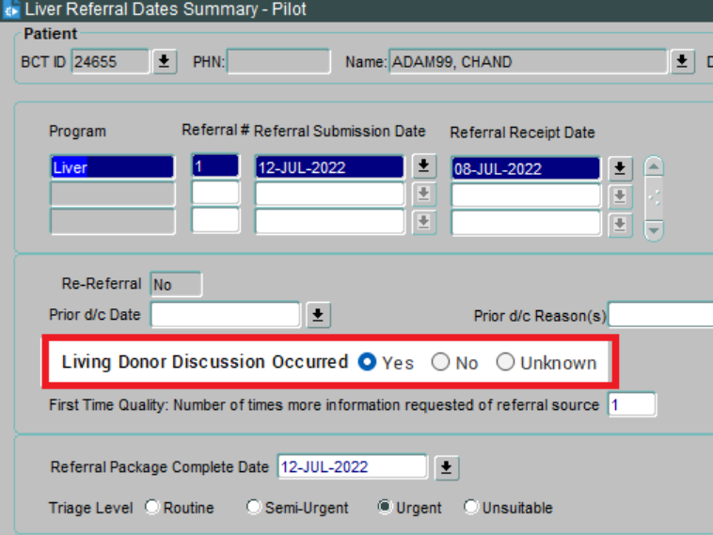

Summary of Changes in Demographics

Navigation:
PROMIS 4 > Patient Overview > Pt. Info > Demographics
- There are two new fields in the Demographics screen:
  - Educational Level
  - Academic Grade Level
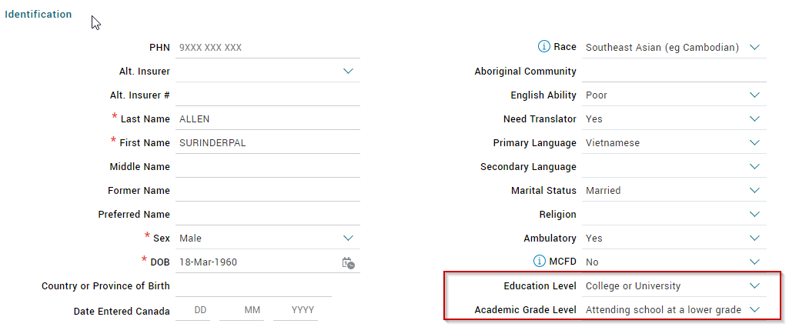

Summary of Changes in Patient Program Status

Navigation:
Classic > Treatment > Patient Program Status
- The Unsuitable status has new values in the End Reason list. The new values are:
- Extrahepatic hepatocellular carcinoma
- High-risk cardiovascular disease
- History of poor medical adherence
- Patient’s condition deteriorated — too sick for transplantation
- Poor life expectancy
- Recent/metastatic malignancy
- Risks outweighs benefits of transplant
- Test outdated
- Ventricular assist device: Bridge to recovery
- UNK: Unknown

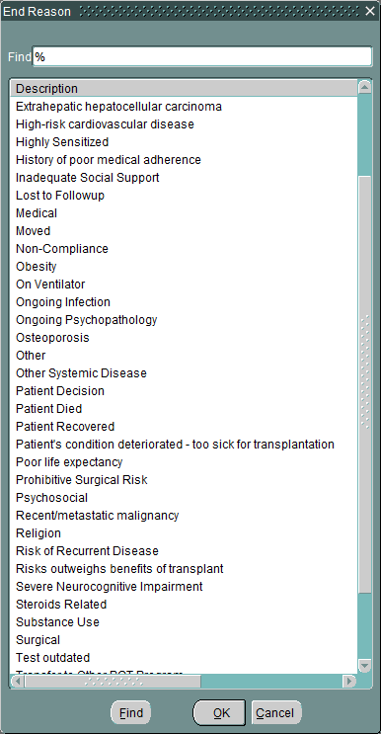

Summary of Changes in Deactivate Transplant

Navigation:
Classic > Patients > Deactivate Transplant
- The Reason drop-down list has new items/reasons on the list:
- Contact Information Outdated
- Patient Refusal
- Other

